Google Apps for Education Student Accounts
- Have students go to www.google.com

- Have students click “sign in”.

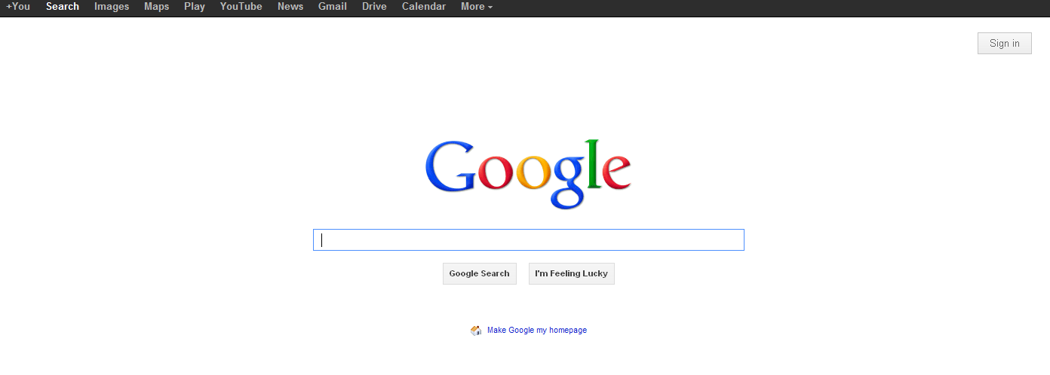

The student’s username is as follows:
firstinitiallastname@students.wvcsd.org
Google Apps is synced with the student’s computer login in, so if the student typically has a number after their name when they log into the computer, they will have to include that here.

- Default password is: password

- Once the username and password is entered, the password window will appear again and then the student will have to input the word password again and the “captcha code” where indicated.

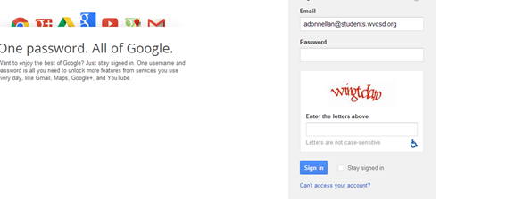

- Students will be brought to the new accounts page and will accept the terms. 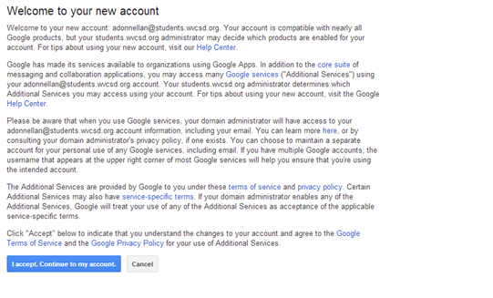

- The students will then be prompted to change their password.
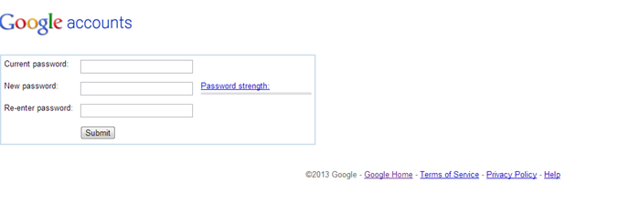

- Students will only be able to receive email from and send email to those within the WCSD domain.

- All email and other activity will be monitored and misuse will result in suspension of the students Google Apps accounts as well as any other disciplinary action set forth by the school and district.

- If there is any difficulty in logging in for the first time, teachers may email the District Instructional Technology Staff Developer, Yvonne Koulikov, and she will reset the student account.

